1.С **mobi-shop** отошлите на **laravel-shop** несколько сообщений от разных пользователей (см.таблицу **users – api_token**):

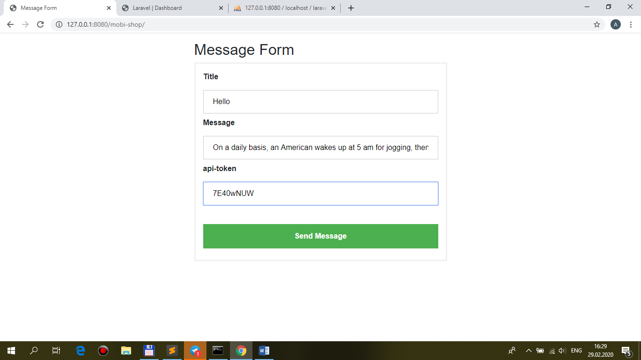

+ views/front/**messages/index.blade.php** **@include('front.messages.brick-standard')**:

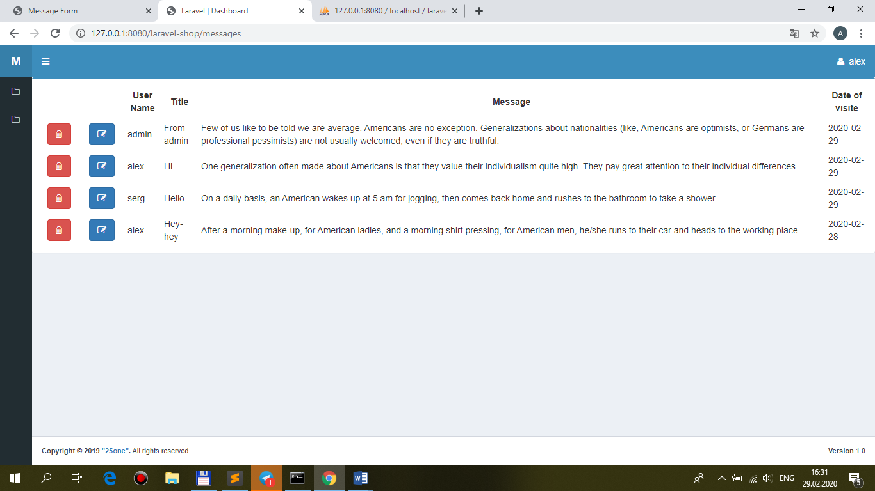

2.Разместите на странице **текстовое поле** и **кнопку** для **поиска по контексту** в **message**:

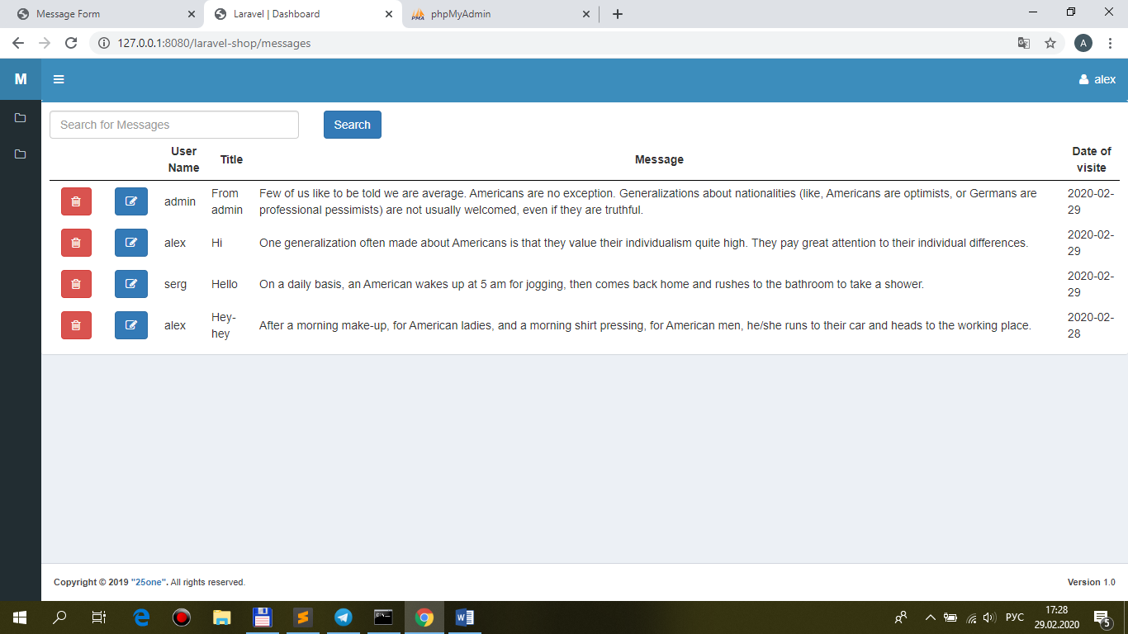

3.Реализуйте **ajax**-поиск **по контексту** по полю **message**:

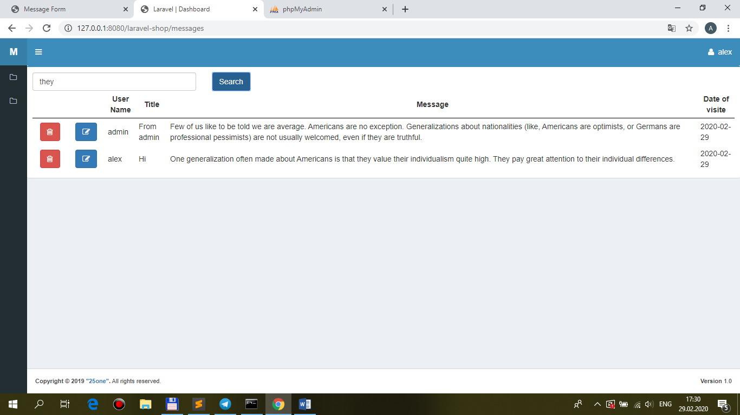

**views/front/messages/index.blade.php**

<div class="row">

<div class="col-md-3 col-sm-3 col-xs-8">

**<input type="text" class="form-control search_text" placeholder="Search for Messages" />**

</div>

<div class="col-md-3 col-sm-3 col-xs-4">

**<button type="button" class="btn btn-primary search_button">Search</button>**

</div>

</div>

…

@section('js')

<script src="{{ asset('public/js/**main.js'**) }}"></script>

<script>

**$(document).ready(function(){**

**$('.search_button').click(function(){**

**BaseRecord.searchMessages($('.search_text').val());**

**});**

**});**

</script>

@endsection

**public/main.js**

searchMessages: function(search_messages){

//alert(value);

var ajaxSetting={

method: 'get',

url: './messages',

data: {

search_messages: search_messages,

},

success: function(data){

//alert(data.table);

$('#pannel').html(data.table);

},

};

$.ajax(ajaxSetting);

},

**MessageController.php**

public function index(Request $request)

{

$messages = $this->repository->funcSelect($request);

// Ajax response

if ($request->ajax()) {

return response()->json([

'table' => view("front.messages.brick-standard", ['messages' => $messages])->render(),

]);

}

return view('front.messages.index', ['messages' => $messages]);

}

**MessageRepository.php**

public function funcSelect($request)

{

$query = $this->model_message

->select('id', 'user_id', 'title', 'message', 'datevisit')

->orderBy('datevisit', 'desc');

if($request->search_messages) $query->where('message', 'like', '%' . $request->search_messages . '%');

return $query->get();

}